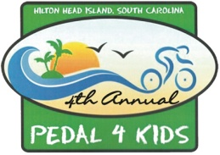
BOYS & GIRLS CLUB OF HILTON HEAD
PEDAL 4 KIDS-TEAM ROSTER CHECK LIST

Adult Registration Fee - $30 Student Registration Fee (ages 6-22)-$10 Family Fun Ride Kids (5 and under) FREE

- Team Roster, Waiver Release Forms, Fees and Donations Due: September 17, 2010
- Pick up Team T-Shirts @ BGCHHI: September 23rd or 24th between 9am to 1pm

Team Name: _________________________Team Captain: ____________________________

Name | Fee  $ | Donation  $ | Form of Payment | Total Payment | T-Shirt Size
1
2
3
4
5
6
7
8
9
10
11
12
13
14
15
16
17
18
19
20
21
22
23
24

